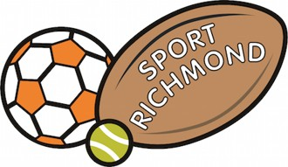

SPORT RICHMOND – CLUB SUPPORT APPLICATION FORM

- TERMS AND CONDITIONS OF APPLICATIONS
Applicants are eligible for a grant if they provide sport within the London Borough of Richmond upon Thames.
Grant amounts are awarded on a case by case assessment up to a maximum of £500.
Clubs will be required to show their own financial support for the project.
Clubs and organisations are limited to one application per financial year (1 April – 31 March) with priority given to new applications.
Focus groups are:
- Under 10s and new starters to sports
- Females
- Over 60s
- Disabled
- Socio-economically challenged groups

Please complete all sections and return to info@sportrichmond.org.uk

If successful:
The grant payment will be confirmed in writing, and a cheque sent to the named representative of the club.
You will be required to share sporting photos and a brief statement for publicity purposes.

- APPLICANT DETAILS
Club / Organisation
Address
Sport
Affiliated club / team

- CLUB STATEMENT
Why are you applying for this grant?
What will it be used for?
What is your 12 month plan if you were successful in achieving this grant?

- DETAILS OF EXPENSES (please add additional lines as required).
Examples: cost of coaching; cost of sporting memberships; cost of travel, accommodation or other tournament costs.

Details | Cost (£)

